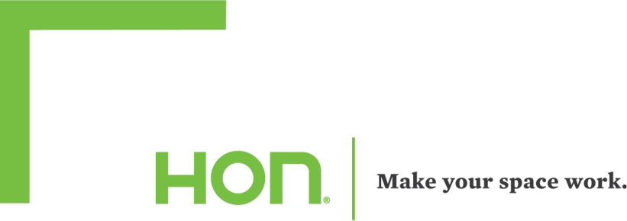

The HON Company – subcontractor and service rates (revised 06.01.23)
State of washington – naspo pa contract # 21422

Complete Office
11521 E. MARGINAL WAY SOUTH, SUITE 100
SEATTLE, WA 98168
CONTACT: GENE KAUTZMAN
PHONE: 206-779-1803
EMAIL: GKAUTZMAN@COMPLETE-OFFICE.COM

The Creative Office
Division of 360 Office Solutions
721 LEGION WAY SE OLYMPIA, WA 98501 CONTACT: SCOTT BREWER PHONE: 360-754-1732
Email: sbrewer@creativeof.com

Design, Installation, layout, And Reconfiguration Service rates.
Charges for these services will be negotiated by the Purchasing Entity on a project-by-project basis with the Designated Subcontractor and included as a line item in the quote provided by the Designated Subcontractor. Contractor may offer, through its Designated Subcontractors or approved freight carrier(s), liftgate services and other non-standard delivery services which are outside of Contractor’s standard freight costs, such as palletization, storage, special permits, etc.; should Contractor be able to offer such non-standard delivery services, these services will be negotiated on a project-by-project basis and approved by the Purchasing Entity. Charges for non- standard delivery services will be included as a line item in the quote provided by the Designated Subcontractor.

